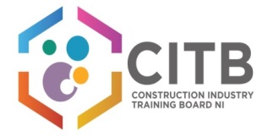

**CITB NI Focus Group Employer Questionnaire**

We value your honesty and your responses are not restricted. Feel free to brainstorm within your organisation.

1. What are the major changes happening in the industry that will require support from CITB NI?
2. What do you believe should be the key purpose of CITB NI’s funding?

* Target specific skills or deliver general support?
* Provide Direct Support (Direct training sourced by CITB NI or direct payment of grants)
* Should it incentivise or reward training?

1. What should the priorities of funding be over the next 3-5years?

1. What levels of qualifications, skills and training should be the greatest priority?
2. What is the best way for CITB NI to deliver training support?

1. How best can CITB NI fund training support?
2. What are the outcomes we should be aiming for from the Levy funding investment?
3. What are the key changes that CITB may need to make in how it uses the Levy funds to support employers’ skills needs?

**Please return questionnaire to by Monday 20 June 2016 to** [**lynn.booth@citbni.org.uk**](mailto:lynn.booth@citbni.org.uk) **or post to CITB NI, 17 Dundrod Road, Crumlin, BT29 4SR**