**Robert Hamilton – Level 3 Carpentry & Joinery**

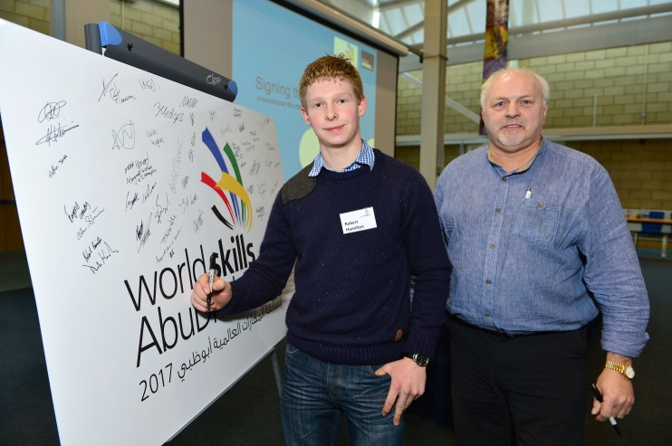Robert Hamilton is currently on the Level 3 in Carpentry and Joinery.  He won GOLD at The Skills Show in Birmingham in November 2014. Robert the youngest competitor in the Carpentry & Joinery Skill Area is a past student of Dunclug College. He then progressed to Northern Regional College to take up his apprenticeship full-time.

Northern Regional College Lecturer, Trevor Kernohan commented "Robert is a dedicated, hard working apprentice who is fully deserving of his success and credit must also go to his employer Mr Rodney Turtle."  Pictured is Robert Hamilton with Trevor Kernohan, Northern Regional College lecturer, signing a pledge to compete for a place in Squad UK for WorldSkills Abu Dhabi 2017 – the worlds largest international skills competition.